**Experiment name**

Classical treatments and/or staining methods

**References**

(Simon et al. 2013) (Platre et al. 2018) (LeBars et al. 2014)

**Material and equipment**

-Nunc cell plates <https://www.thermofisher.com/fr/fr/home/life-science/cell-culture/cell-culture-plastics/cell-culture-plates.html>

-Stocks solution (see table below)

**Hardware**

|  |  |  |  |  |  |  |
| --- | --- | --- | --- | --- | --- | --- |
| Microscope | Configuration | Laser properties (wavelength + intensities) | CLSM Detector  (detection window + gain) | Exposure time (spinning) | Other parameters  (Z-stack, time lapses) | Comments |
|  |  |  |  |  |  |  |
|  |  |  |  |  |  |  |

**Biological material**

Line used for the experiments: Good controls (both positive and negative)

|  |  |  |
| --- | --- | --- |
| Marker lines | Resistance | Expected result |
|  |  |  |
|  |  |  |

**Other material**

|  |  |  |  |
| --- | --- | --- | --- |
| Reference | Concentration (stock) | Concentration (final) | Comments |
| BrefeldinA Sigma B7651) | 50mM in DMSO | 25µM  30µM (Lebecq et al. 2021) | 60’ |
| Concanamycin A | 100µM in DMSO | 1µM | Vacuolar ATPase inhibitor, prevent vacuolar degradation and autophagic bodies accumulation |
| Latrunculin B | 10mM in DMSO | 10µM |  |
| Oryzaline Sigma PS410 |  | 20µM |  |
| Phenylarsine oxide (PAO) Sigma P3075 | 60mM in DMSO | 60µM | 30’ |
| Wortmaninn (Sigma W1628  ) | 30mM in DMSO | 30µM | 90’ |
| FM4-64 (thermoFisher T13320) | 1.645 mM=1 mg/ml in DMSO | 1µM | Plasma membrane and endocytic pathway 60’ |
| Propidium Iodide |  | 20mg/ml H20 | Cell wall staining |

**Time and technical constraint**

Describe here if there is stuff to anticipate. Solution prep, coverslips cleaning etc…

**Precise description of the method**

FM4-64: 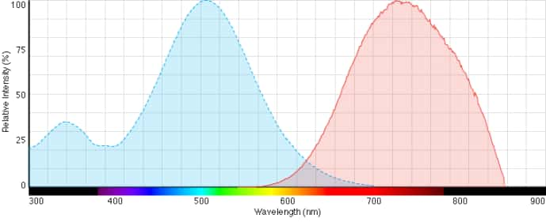

Propidium Iodide : 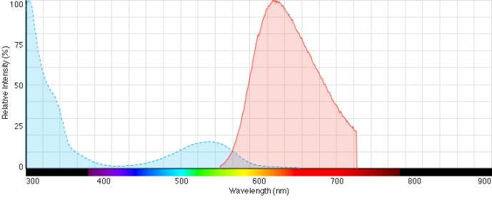

Platre et al 2018:

The plasma membrane and endosomes of 5 to 7-day old transgenic lines expressing mCITRINE-C2LACT were stained by incubating roots with 1 μM FM4-64 (thermofisher scientific, [www.thermofisher.com](http://www.thermofisher.com)) liquid MS solution for 60 min.

Lines co-expressing mCITRINE-C2LACT and VHA-A1-RFP were incubated in wells containing 25 μM Brefeldin A (BFA, Sigma, [www.sigmaaldrich.com](http://www.sigmaaldrich.com), BFA stock solution at 50 mM in DMSO) liquid MS solution for 60 min. Lines co-expressing mCITRINE-C2LACT and W7R were incubated in wells containing 30 μM Wortmannin (Sigma, [www.sigmaaldrich.com](http://www.sigmaaldrich.com), WM stock solution at 30 mM in DMSO) liquid MS solution for 90 min.

Lines co-expressing mCITRINE-C2LACT with compartment markers (W25R, W13R, W18R, W7R) and 2xmCITRINE8K-FARN (8+) with compartment markers (W25R, W34R W7R) and 2xmCITRINE4K4Q-FARN (4+) with compartment markers (W25R, W13R, W18R, W7R) were incubated in wells containing 60 μM PAO (Sigma, [www.sigmaaldrich.com](http://www.sigmaaldrich.com), PAO stock solution at 60 mM in DMSO) liquid MS solution for 30 minutes. For each treatment, the mock condition corresponds to incubation of plants in well supplemented with a volume of DMSO equivalent to the highest drug concentration used and for the same time as the actual treatment. In all cases, roots were imaged within a 10-minute time frame window around the indicated time.

Lebecq et al. 2022

Seedlings were incubated in wells containing 1 µM FM4-64 (Life Technologies T-3166; from a stock solution of 1.645 mM=1 mg/ml in DMSO) in half Murashige and Skoog (½ MS) liquid basal medium without shaking for 30 min and in dark. Seedlings were then mounted in the same medium and imaged within a 10 min time frame window (1 hr ± 5 min).

Seedlings were incubated in wells containing Brefeldin A (BFA; Sigma B7651) applied at 50 µM (from a stock solution of 30 mM in DMSO), or a corresponding volume of DMSO as ‘mock’ treatment, dissolved in liquid ½ MS for 1 hr in dark without shaking before mounting in the same medium and imaging. For co-treatment with 50 µM BFA and 1 µM FM4-64, FM4-64, and BFA were added at the same time. Imaging was performed within a 14 min time frame window (1 hr ± 7 min).

For PAO treatment, seedlings were incubated in wells containing 30 μM PAO (Sigma P3075, <https://www.sigmaaldrich.com/IN/en>, PAO stock solution at 60 mM in DMSO), or a volume of DMSO as mock treatment, during the indicated time. Roots were imaged within a 10 min time frame window around the indicated time.

Bayle et al. 2011

BFA (50 mM; Sigma-Aldrich), Wortmannin (20 mM; Sigma-Aldrich), concA (100 μM; Sigma-Aldrich), and MG-132 (50 mM; Calbiochem) stock solutions were prepared in DMSO and used at 50, 33, 0.5, and 50 μM, respectively, in liquid +P or –P medium according to the experiment. For control experiments, a 0.5% DMSO solution was used. CHX (50 mM; Sigma-Aldrich) stock solution was prepared in water and used at 50 μM for experiments. Various drug effects were assayed on 9-d-old plantlets.

For FM4-64 staining, roots were incubated with 5 μM FM4-64 (Red synaptracer 3.2; Interchim) for 10 min on ice, washed twice with +P or –P liquid medium, and observed at different incubation times. The cell wall was stained with propidium iodide (20 mg/mL).

Le Bars et al. 2015

For concanamycin A (Fluka, 27689) and wortmannin (Sigma, W1628) treatments, liquid medium was supplemented with, respectively, 1 and 30 μM of the chemical, diluted from frozen aliquoted stocks in dimethyl sulphoxide. Concanamycin A was added for the whole duration of the starvation treatment, while wortmannin was added only for the last 1 h. An equivalent volume of dimethyl sulphoxide was added to the controls.